Apple fruit surface temperature prediction using weather data-driven machine learning models

Nelson D. Goosman   
*School of Electrical Engineering and Computer Science   
Washington State University*Pullman, Washington, USA  
nelson.goosman@wsu.edu

Basavaraj R. Amogi  
*Department of Biological Systems Engineering*  
*Washington State University*Prosser, Washington, USA  
basavaraj.amogi@wsu.edu

Lav R. Khot  
*Department of Biological System Engineering*  
*Washington State University*Pullman, Washington, USA  
lav.khot@wsu.edu

*Abstract*— Heat stress to maturing apple fruits is a key concern to tree fruit growers in the Pacific Northwest region of the United States and around the globe. Localized weather- based fruit surface temperature (FST) prediction, a key indicator of fruit stress, can help in planning better mitigation strategies and ultimately reduce crop losses during harvest. Therefore, this study evaluates localized weather (solar radiation, temperature, relative humidity, dew point, and wind speed) and fruit size data driven multiple linear regression (MLR) and Long Short-Term Memory (LSTM) models for predicting apple FST. The models were trained on either of the localized in-orchard or open field weather station data collected in the 2022 field season and validated against the actual FST of Honeycrisp cultivar. The MLR model was able to predict FST with an average root mean square error (RMSE) of 2.1 ℃ using the in-orchard weather and fruit size dataset as input. The LSTM model prediction average RMSE for the same dataset was 2.3 ℃. Additionally, this model outperformed existing energy balance FST prediction approach. Overall, findings highlight the use case for real-time and reliable FST monitoring using localized and communally available weather data inputs.

Keywords— apple, fruit surface temperature, heat stress, machine learning

# Introduction

With global temperature changing towards warm anomalies [1], fresh market apple fruit crop production is becoming a demanding task. In the Pacific Northwest region of the United States, hot summer days with elevated air temperature and intense solar radiation (heat stress) cause sunburn and heat stress related fruit disorders [2]. To mitigate the losses, growers use overhead cyclic rotating sprinklers, foggers, netting, and protectant sprays [3]. However, precise data inputs are needed for actuation and effective use of some of these mitigation techniques (e.g., regulating the cyclic nature of overhead sprinklers and precision actuation of foggers).

Sunburn is a thermal death of epidermal and subepidermal cell (peel) of the fruits. The fruit surface temperature (FST) [4] is a known determinant of thermal death. Therefore, prediction of FST as an indicator of heat stress to fruits, can help growers in timely mitigation of the stress. FST can be easily estimated using a contact type thermocouple probe inserted into fruit peel. Estimation of FST directly with such probes is not only impractical but also laborious and invasive as continual monitoring approach. Therefore, non-invasive methods of FST estimation were developed using thermal-RGB imaging data processed in real-time on single board computers [5], [6] and weather data as an input to energy balance equations [7]. The downside of localized imaging method is that it can be hyper local sensing with node performance affected by harsh outdoor environments. Thermal imager accuracy can also drift over time and need periodic recalibration, making it challenging for growers to rely on this approach. Alternate is to use generalized weather data-based energy balance approach [7]. The latter requires fruit morphological inputs (size and color), in addition to several assumptions made on variables related to radiative heat balance. This makes the above approaches somewhat inaccessible or use prohibitive for growers. The need is to have a simplistic model that can reliably predict FST for growers to effectively actuate heat stress mitigation techniques.

Pertinent to this, the study goal was to develop a simplistic approach of continuous FST estimations that can be made available to growers in near real-time. As open- and in-field weather stations and associated data can be collected reliably by growers or regional networks [8] (e.g., WSU AgWeatherNet, http://www.weather.wsu.edu/), having model based on such data was considered as an ideal solution. It was hypothesized that a machine learning (ML) approach with key weather parameters as input can help model and reliably estimate FST. Specific study objective was to develop and evaluate performance of weather data-based apple FST estimation models for Honeycrisp cultivar using regression and recurrent neural networks.

# Materials and methods

## Data collection

The experimental site was a commercial Honeycrisp orchard block located in central Washington. The orchard block had four different types of heat stress mitigation techniques, i.e., conventional overhead sprinklers, low volume foggers, shade netting, foggers installed underneath netting, and control with no heat mitigation. In each treatment, the crop physiology sensing system (CPSS) nodes were deployed to monitor FST using thermal-RGB imagery every 5-min and collect in- and above- canopy weather data (Fig. 1a) [5], [6] using localized sensors (ATMOS14/41, Meter Group, Pullman, WA, USA) at 1 Hz, throughout the season. The weather data used in this study includes in-canopy air temperature (℃), wind speed (m/s), dew point (℃) and above canopy solar radiation (W/m2). The actual FST (℃) data was collected, as a ground truth, between July 12 and July 29, 2022, for the five hottest days during heat stress hours (12.00 h to 18.00 h). Actual FST was measured using a handheld contact type thermocouple (Thermapen Blue, ThermoWorks Inc., American Fork, UT, USA) (Fig. 1b). The thermal-RGB FST measured by the CPSS nodes was discarded in favor of probe based FST measurement.

An open-field weather station located outside the orchard recording the same weather parameters as the in-orchard sensing nodes was used as a base comparison to the in-orchard data. The open-field weather station had a weather sensor (ATMOS41) installed at 1.5 m above ground level (Fig. 1c).

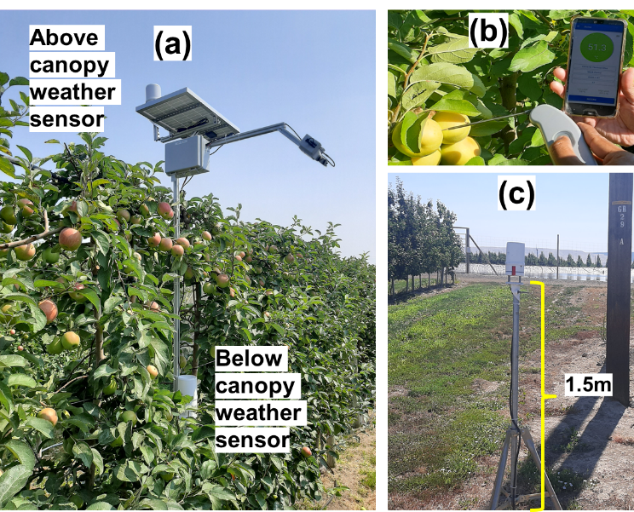

1. (a) Above and below canopy weather sensors installed in orchard to collect localized weather data, used to train machine learning models to predict actual fruit surface temperature collected using (b) handheld thermocouple. The models were also trained on (c) Open-field weather data with sensor installed at 1.5 m above ground level for comparison against predicted FST using in-orchard data.

Apple fruit diameter (mm) was also measured and used as an additional input to the model as a measurement to indicate heat transfer by surface area. Only the fruits with the warmest temperature needed to be predicted to avoid overall damage due to sunburn, so cooler fruits located in the canopy shade were ignored. Additionally, the type of mitigation techniques used to alter the orchard microclimate should not be relevant as it is already factored into the localized weather and fruit size data.

## Machine learning model development

Two different algorithms to model and estimate apple FST were used: multi-linear regression (MLR) and Long Short-Term Memory (LTSM) [9]. Both models were built in Python (ver. 3.10) using the Pytorch library (ver. 2.0.1). Models were backpropagated with mean squared error (MSE) loss and used Adams optimization method with a weight decay of 0.0001. As an optimization parameter, the LSTM uses AMSGrad [10] in addition to Adam. Models were executed on the GPU (Nvidia GeForce RTX 2070) using built in Pytorch optimization capabilities to decrease training time.

The models were built using in-orchard as well as open-field weather data separately, with and without actual fruit size. Actual FST was assigned as a target variable to predict using air temperature, above canopy solar radiation, wind speed, dew point, time of day as a fraction of 24 hours (e.g., hour of day / 24), and day of year as a fraction of 365 as independent variables, which were then normalized to the range [-1, 1]. To train and validate each model, the data were partitioned to have 80% of the data randomly selected as training data and the other 20% as validation data (568 training datapoints, 142 validation datapoints). In both models, the linear layers use ReLu activation functions. For the MLR model, the validation data was randomly selected from the database, however because LTSMs require chronological data, the data were first “windowed” into intervals of 35-time steps before shuffling.

Due to the randomization of model weights and biases during training, the outcomes of the model can vary slightly each time it is trained. Thus, the MLR and LSTM models were trained and validated thrice on randomized 80:20 dataset to report the averaged performance.

Additional specific details on MLR, LSTM and energy balance models are as follows:

### MLR

The architecture used to train the MLR model employed weather data as the input layer, two hidden layers, and predicted FST as output layer. The first hidden layer contains 6 nodes while the second layer contains 3 nodes, and the final layer outputs the singular FST prediction. The learning rate was 0.0005 and the model was trained for 100 epochs with a batch size of 48.

### LSTM

The LSTM architecture contained an initial two LSTM layers of 20 nodes each with a dropout probability rate of 0.3 applied to output of the first layer before it is fed into the second LSTM layer. Finally, the output of the second LSTM layer is fed through two fully connected linear layers containing 10, and 5 nodes each in order to extract the most prevalent features of the data from the initial LSTM prediction. The output linear layer then yields a singular prediction of FST. Additionally, the LSTM model uses windowed data with a window size of 35 as input such that for each timestep of data, the model can view the previous 34 timesteps as additional information as well as the current timestep. The LSTM model was trained with a learning rate of 0.0001 over 500 epochs and contained a batch size of 32.

### Energy Balance

To validate MLR and LSTM models against similar FST prediction techniques, an existing weather-based energy balance model was used [11] to predict FST. The energy balance model input includes weather parameters such as air temperature, dew point, wind speed, solar radiation, and ground temperature as well as individual crop parameters such as fruit emissivity (ɛ), fruit diameter, fruit albedo (α) and projected sunlit fruit surface ratio (*r*). FST was estimated for same in-orchard weather data and measured fruit diameter used to train MLR and LSTM models. The estimations were done for ɛ, α, and *r* with 0.95, 0.30, and 0.5, respectively [6].

### Model performance evaluation

MSE and Root Mean Squared Error (RMSE) defined as in (1) and (2) respectively, were used to assess the model performance.

MSE = (1)

RMSE = (2)

Where, is the actual data point observation, is the estimated outcome produced by the model, and N is the total number of predictions made.

# results

Table 1 summarizes the model performance against the validation dataset. In case of MLR model trained on in-orchard data containing fruit size, the RMSE was in the ranges of 2.08 – 2.13 ℃ with an average RMSE of 2.12 ℃ (standard deviation [SD] = 0.03). The average R squared value of the regression was 0.70, suggesting that the model may need additional input parameters for improved fit. Given that the handheld contact type thermocouple used has an error margin of 0.4 ℃, it is reasonable to assume that some of this variance comes from this inaccuracy. Overall, a MLR model trained on in orchard data with fruit size as an additional parameter yields the most accurate results compared to other models and training data combinations. The MLR FSTs prediction absolute error was ≤ 3.32 ℃ for 88% of the validation dataset (fig. 2).

Table I. Performance of FST Prediction models against the validation dataset

|  |  |  |  |  |  |
| --- | --- | --- | --- | --- | --- |
| Input Data | | Error  +(℃) | Model Type* | | |
| Weather | Fruit size | MLR | LSTM | EB |
| Open Field | Yes | MSE  RMSE | 5.08±0.25ll  2.25±0.05 | 7.31±0.85  2.69±0.16 | N/A |
| No | MSE  RMSE | 8.07±0.09  2.84±0.04 | 11.32±0.35  3.36±0.05 | N/A |
| In-Orchard | Yes | MSE  RMSE | 4.49±0.09  2.12±0.03 | 5.38±0.31  2.32±0.01 | 23.61 ± 6.34  15.37± 0.21 |
| No | MSE  RMSE | 4.84±0.06  2.19±0.01 | 6.0±0.66  2.45±0.13 | N/A |

*MLR: multilinear regression, LSTM: Long short-term memory, EB: Energy balance

+MSE: mean square error, RMSE: root mean squared error

ll mean ± Std. Dev.

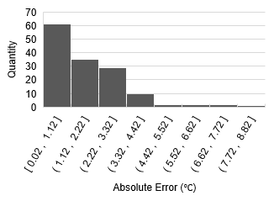

1. Absolute FST prediction error histogram for one of the multilinear regression model validation run with fruit size and in field weather data inputs.

The MLR model's tendency to inaccurately estimate FST values could either result from those values being outliers or from the model being unable to recognize timeseries trends leading up to a large increase in FST. If that is true, an LSTM should provide better results. However, findings from this study did not support this argument (fig. 3). Based on the accuracy of the LSTM model from an average of three trials of randomly selected in orchard training and validation data, the LSTM RMSE was in the ranges of 2.35 – 2.2 ℃ with a mean RMSE of 2.32 ℃ (SD = 0.01) for in-orchard weather data-based training and validation with fruit size as an additional parameter. Overall, a MLR model provided better accuracy on the test dataset than the LSTM model. For both models, however, fruit size does appear to slightly increase the accuracy of FST predictions. Fruit size has the greatest impact on FST prediction when used with open field data. In table 1, model accuracy increased by 0.67 ℃ in the LSTM model and 0.59 ℃ in the MLR model with fruit size data as an additional model input parameter.

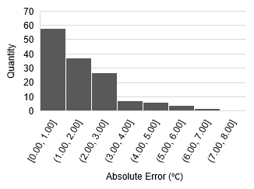

Fig. 3. Absolute FST prediction error histogram for one LSTM model validation run with fruit size and in weather data inputs.

Both LSTM and MLR models consistently outperformed the existing energy balance model on the same dataset (table 1). To ensure consistency in the comparison of these models, we randomly selected 142 data points from base dataset to have validation set size matched to that of the ML models. On these datapoints, the RMSE was 15.37 ℃ (SD = 0.21) representing a significant decrease compared to MLR and LSTM model accuracies. In fig. 4, we can see that many of the predictions from the energy balance model have an absolute error in the range 9.14 – 23.64 ℃.

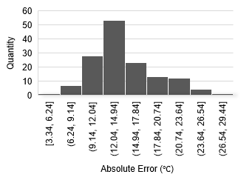

1. Absolute FST prediction error histogram for one trial of the energy balance model validation run with in field weather data inputs and fruit size.

Another factor that influences model performance is the location of the weather station that the data is sourced from. Results showed that the MLR and LSTM models trained on in-orchard data using the exact same input parameters performed better (see Table 1) than models trained on open field weather data.

# conclusions

This study highlights the use case of machine learning models in FST prediction using real-time weather data from open- and in-field weather stations and associated data collected by growers or regional networks. Overall, a higher degree of accuracy can be obtained using a multi linear regression model on in-orchard data, which performed better than existing energy balance methods of FST prediction as well as a LSTM model approach. The MLR model was able to predict FST with RMSE below 1.8 ℃ for 88% of the validation dataset. These models only need weather and fruit size as input parameters providing greater ease of use by the growers as a practical method of FST prediction. The energy balance RMSE averaged at 15.37 ℃ (SD = 0.21) while the MLR models average RMSE was 2.12 ℃ (SD = 0.03). Overall, this study showcases a potential for FST prediction with commonly available weather data from either in-orchard or open field data as a possible solution for real time FST prediction.

# Acknowledgment

This study was funded in-part by USDA-NIFA/NSF Cyber-Physical Systems program, WNP0745, and Washington Tree Fruit Research Commission. Any opinions, findings, conclusions, or recommendations expressed in this publication are solely of the authors. The authors acknowledge Hancock Farmland Operations and Jain-USA for their in-kind support. We want to thank Nisit Pukrongta, Karisma Yumnam, Srikanth Gorthi, from WSU Precision Agriculture lab for helping with field installation and actual FST data collection. We also would like to thank Nicholas Kraabel for input on LSTM training and optimization methods.

##### References

[1] NOAA, “June 2023 Global Climate Report | National Centers for Environmental Information (NCEI),” 2023. https://www.ncei.noaa.gov/access/monitoring/monthly-report/global/202306 (accessed Jul. 15, 2023).

[2] L. Schrader, J. Zhang, and J. Sun, “Environmental stresses that cause sunburn of apple,” *Acta Horticulturae*, vol. 618, pp. 397–405, 2003, doi: 10.17660/ActaHortic.2003.618.47.

[3] J. Racsko and L. E. Schrader, “Sunburn of Apple Fruit: Historical Background, Recent Advances and Future Perspectives,” *Critical Reviews in Plant Sciences*, vol. 31, no. 6, pp. 455–504, 2012, doi: 10.1080/07352689.2012.696453.

[4] L. E. Schrader, J. Zhang, and W. K. Duplaga, “Two types of sunburn in apple caused by high fruit surface (peel) temperature,” *Plant Health Progress*, vol. 2, no. 1, p. 3, 2001.

[5] B. Amogi, R. Ranjan, and L. R. Khot, “Reliable image processing algorithm for sunburn management in green apples,” in *2022 IEEE Workshop on Metrology for Agriculture and Forestry (MetroAgriFor)*, 2022, pp. 186–190.

[6] R. Ranjan, L. R. Khot, R. T. Peters, M. R. Salazar-Gutierrez, and G. Shi, “In-field crop physiology sensing aided real-time apple fruit surface temperature monitoring for sunburn prediction,” *Computers and Electronics in Agriculture*, vol. 175, no. March, p. 105558, 2020, doi: 10.1016/j.compag.2020.105558.

[7] L. Li, T. Peters, Q. Zhang, J. Zhang, and D. Huang, “Modeling Apple Surface Temperature Dynamics Based on Weather Data,” pp. 20217–20234, 2014, doi: 10.3390/s141120217.

[8] F. J. Pierce and T. V. Elliott, “Regional and on-farm wireless sensor networks for agricultural systems in Eastern Washington,” *Computers and Electronics in Agriculture*, vol. 61, no. 1, pp. 32–43, 2008, doi: 10.1016/j.compag.2007.05.007.

[9] S. Hochreiter and J. Schmidhuber, “Long short-term memory,” *Neural computation*, vol. 9, no. 8, pp. 1735–1780, 1997.

[10] S. J. Reddi, S. Kale, and S. Kumar, “On the convergence of Adam and beyond,” *6th International Conference on Learning Representations, ICLR 2018 - Conference Track Proceedings*, pp. 1–23, 2018.

[11] L. Li, T. Peters, Q. Zhang, and J. Zhang, “Modeling apple surface temperature dynamics based on weather data,” *Sensors (Switzerland)*, vol. 14, no. 11, pp. 20217–20234, 2014, doi: 10.3390/s141120217.